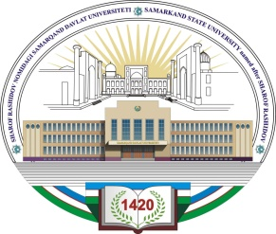
SHAROF RASHIDOV NOMIDAGI
SAMARQAND DAVLAT UNIVERSITETI

ANKETA FORMASI

Familyasi:_________________________________
Ismi:_____________________________________
Otasining ismi:____________________________

Fakultet: __________________________________________________________________________
Ta’lim yo‘nalishi: (o‘zbek/rus) ________________________________________________________ _______________________________________________________________________________.
Ta’lim turi:(kunduzgi/kechgi/sirtqi) ____________________________________

Jinsi: _________________________________________
Tugilgan kun/oy/yil:______________________________
Tugilgan joyi:___________________________________
Millati:___________ _____________________________
Ma’lumoti (qaysi o‘quv yurtini qachon va qaerda tugatgan): _______________________________
____________________________________________________________________________________
Pasport seriyasi va raqami:__________________________________________________________
Kim tomondan /qachon berilgan:_______________________________________________________
Oilaviy ahvoli:____________________________________________________________________
(oilasi va farzandlari haqida ma’lumot ularning yashash joyi)
Ota-onasi haqida ma’lumot:
Ota:________________________________________________________________________________
Ona:_______________________________________________________________________________
(yashash joyi va ish joyi)
Tel/email:______________________________________________
Shaxsiy manzili:
a)__________________________________________________________________________________ ^{doimiy yashash joyi}
b) _________________________________________________________________________________ vaqtinchalik yashash joyi
“____”________________20___
F.I.O (shaxsiy imzo)

